Unit 4: The Constitution Lesson 4- The Remaining Articles of the Constitution
- Essential Question: What powers of the federal government do Articles IV-VII include?
- Article IV- The States
  - Outlines the duties states have to each other
  - Outlines the duties the federal government has to the states

- Article V- Making Amendments

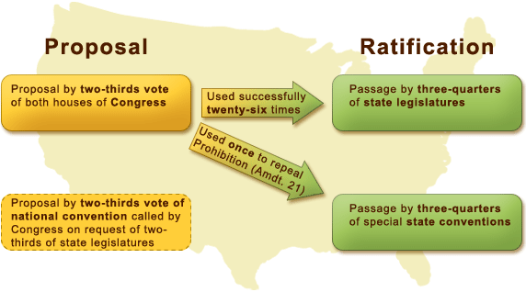
- Article VI- The Supremacy Clause

- Article VII- Ratification

